

Modular Matrix Switch

version
V1.0_20201230
for Android



KENSENCE Technology Development Co.,Ltd.
Tel.: +86-0755-27802825
email: web@kensence.com
http://www.kensence.com

- User Login

Open the application, input the IP address and port, and click the "CONNECT" button to connect the device. (Figure 1)
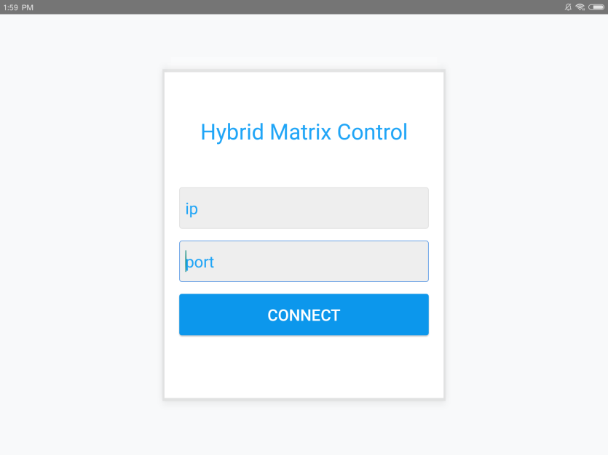
Fig. 1
- Main Interface

The software main interface is divided into 3 parts: INPUT, OUTPUT and SCENE. The software can recognize the size of the matrix automatically. As shown in Figure 2 is a mixing matrix of 20x20.
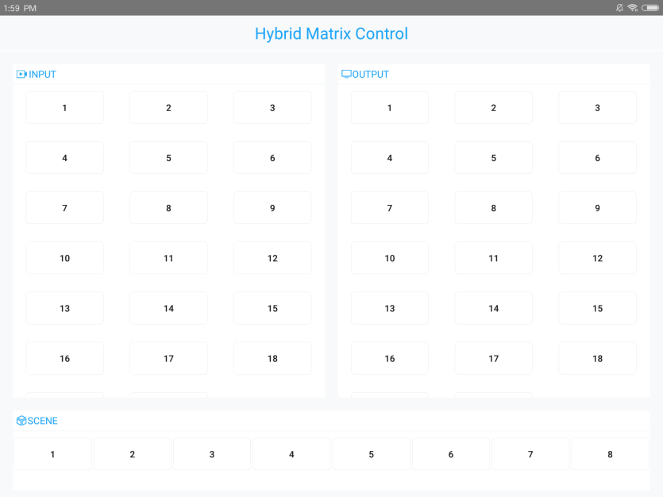
Fig. 2

- Channel Switching

The left is the INPUT (signal source port) and the right is the OUTPUT (display port). Each number button corresponds to its I/ O channel. When selected, the button border turns blue.

When switching, click the input channel, and then click the output channel (can choose more than one), and the switching is completed. As shown in Figure 3, Input 8 switches to Output 10 and Output 14.
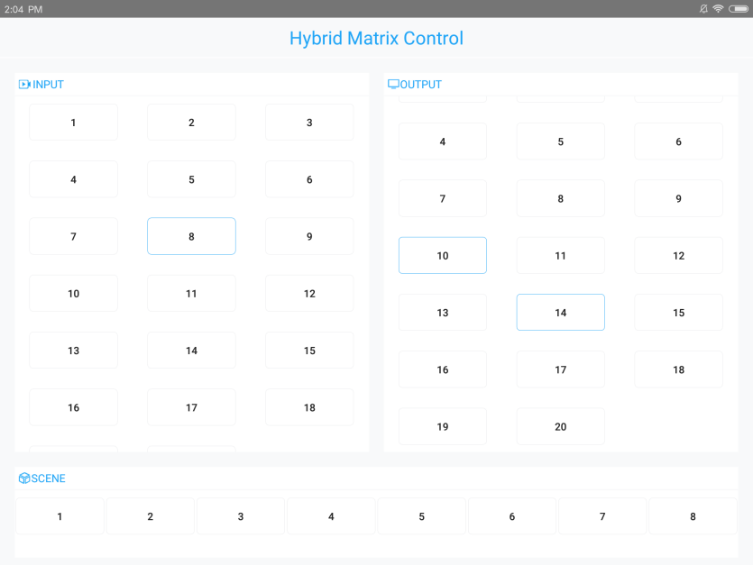
Fig. 3
If you need to rename the channel, long press the button. (Figure 4)
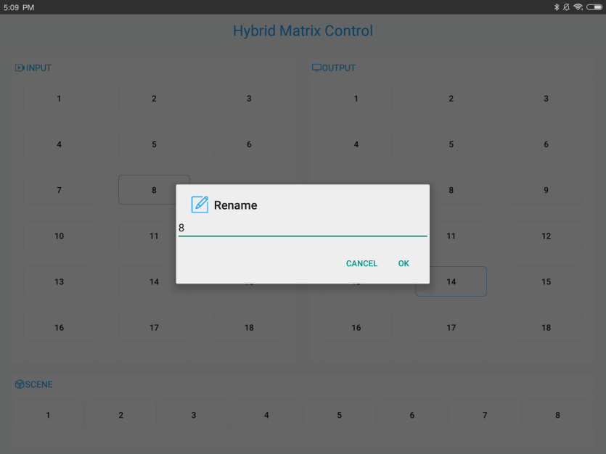
Fig. 4
- Scene Management
- Save scene: After switching the current scene, click the scene number to be saved in the scene list, and then click "SCENE SAVE".
- Call scene: Click the scene you want to call, and then click "SCENE CALL".
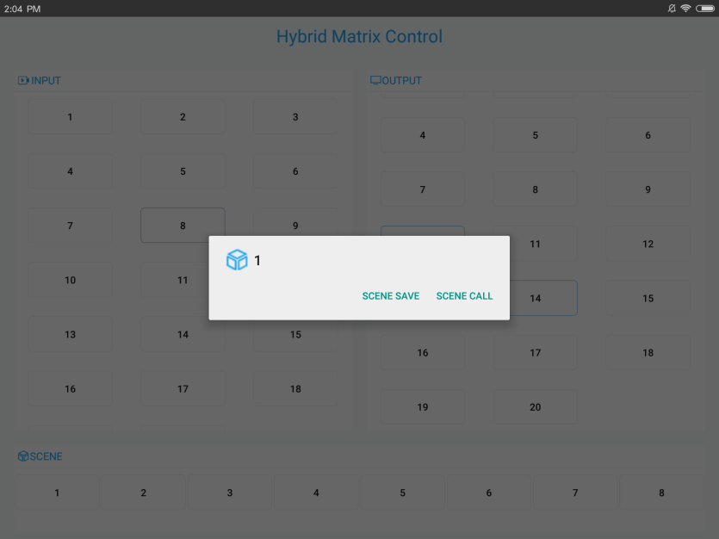
Fig. 5

